**Table of Contents**

3.0 Overview 1

3.1 Data Collection Methods 1

3.1.1 Questionnaire 1

3.1.1.1 Advantages of Questionnaires 2

3.1.1.2 Disadvantages of Questionnaires 2

3.1.2 Interview 3

3.1.2.1 Advantages of face-to-face interviews 3

3.1.2.1 Disadvantages of face-to-face interviews 3

3.2 Questionnaire Planning and Analysis 4

3.2.1 Objectives and Design 4

3.2.2 Purpose of Questionnaire Questions 6

3.2.3 Analysis 7

3.3 Interview Planning and Analysis 26

3.3.1 Objectives 26

3.3.2 Purpose of Interview Questions 28

3.3.3 Interview Transcripts 29

3.3.3.1 Transcript of interview – 1 29

3.3.3.2 Transcript of Interview – 2 31

3.3.3.3 Transcript of Interview – 3 33

3.3.3.4 Transcript of Interview – 4 35

3.3.3.5 Transcript of Interview – 5 37

3.3.3.6 Transcript of Interview – 6 39

3.3.4 Analysis 41

3.4 Functional and Non-Functional Requirements 45

3.4.1 Functional Requirements 45

3.4.2 Non-Functional Requirements 45

3.5 System Design 46

3.5.1 Rich Picture Diagram 46

3.5.2 Use Case Diagram 46

3.5.2.1 Actors and Use Cases 46

3.5.2.2 Login and Registration Diagram 48

3.5.2.3 Rate of Vaccination Prediction Diagram 49

3.5.3 Activity Diagram 50

3.5.4 System Process Diagram 51

3.6 User Interface Design 52

3.6.1 Login and Registration Page 52

3.6.2 Select Countries 53

3.6.2 Select Date 54

3.6.3 Display Page 55

3.7 Summary 55

References 56

Appendix 57

Figure 3.1 Question 1 8

Figure 3.2 Question 2 9

Figure 3.3 Question 3 9

Figure 3.4 Question 4 10

Figure 3.5 Question 5 11

Figure 3.6 Question 6 12

Figure 3.7 Question 7 13

Figure 3.8 Question 8 14

Figure 3.9 Question 9 15

Figure 3.10 Question 10 16

Figure 3.11 Question 11 17

Figure 3.12 Question 12 18

Figure 3.13 Question 13 19

Figure 3.14 Question 14 part 1 20

Figure 3.15 Question 14 part 2 20

Figure 3.16 Question 14 part 3 21

Figure 3.17 Question 15 21

Figure 3.18 Question 16 22

Figure 3.19 Question 17 part 1 23

Figure 3.20 Question 17 part 2 23

Figure 3.21 Question 18 24

Figure 3.22 Question 19 24

Figure 3.23 Question 20 part 1 25

Figure 3.24 Question 20 part 2 25

Figure 3.25 Question 21 26

Figure 3.26 Rich Picture Diagram 47

Figure 3.27 Login and Registration Diagram 50

Figure 3.28 Rate of Vaccination Prediction Diagram 51

Figure 3.29 Display Vaccination Prediction Diagram 52

Figure 3.30 System Process Diagram 53

Figure 3.31 Login and Registration Pages 54

Figure 3.32 Country Selection Page 55

Figure 3.33 Date Selection Page 56

Figure 3.34 Vaccination Prediction Page 57

Table 3.1 Research Objectives and Questions 6

Table 3.2 Purpose of Questionnaire Questions 7

Table 3.3 Design Structure – Interview 28

Table 3.4 Purpose of Interview Questions 29

Table 3.5 Actor and Use Cases 49

# Chapter 3: System Specification and Design

## 3.0 Overview

For this chapter the author outlines the data collection procedure and the methods that have been utilized as well as their benefits and drawbacks. In addition, the author evaluated the data that has been gathered through the data gathering methods that have been used. The author has also used a variety of diagrams as a representation for the system. The diagrams used are rich-picture, activity, use case and sequence diagrams. Moreover, the author has created sketches of the system interface to provide a rough idea of what the proposed system will look like.

## 3.1 Data Collection Methods

Data collection methods are processes of gathering information from all relevant sources in order to find solutions to the research topic, test the research hypotheses, and evaluate the results. Methods of data collection may be divided into two categories. These being primary and secondary data collection methods.

Primary data collection can further be divided into two categories. These categories being qualitative and quantitative data collection. Qualitative data collection methods omit numbers and quantitative computations and rely solely on words, feelings, emotions, opinions and other non-quantifiable components. Quantitative data collection methods on the other hand are such as surveys or questionnaires which have close-ended questions and collects data on the basis of mathematical calculations.

Secondary data gathering methods are such as information that has already been published in books, research articles, journals, newspapers, etc. The data gathered using secondary data gathering methods is that which has been collected by someone other than the primary user.

Data collecting is a crucial part of conducting a research project. Collecting inaccurate data however can have a negative impact on the outcome of the study and may eventually lead to erroneous conclusions thus jeopardizing the validity of the study and its reliability. Through this perspective the data that has been collected by the author has been through the use of questionnaires and interviews.

### 3.1.1 Questionnaire

Questionnaires as a data collecting method is a well-known and important tool used when conducting any type of research when collecting information from participants such as their social traits, their conduct whether past or present, their patterns of behaviors or attitudes, their beliefs and their reasoning behind their actions with regard to the issues that are under examination.

The data collected from questionnaires can be either structured or unstructured this providing quantitative and qualitative data. Despite being proven to be very effective when carrying out research questionnaires have their own set of advantages and disadvantages. A well-designed questionnaire has the benefit of being efficient in that it can collect a lot of data in a short amount of time, is incredibly cost effective because it comes with a large number of capabilities for designing, distributing and analyzing data and is also easy to create through the many tools found online that allow to easily create and distribute the questionnaires such as Google Form, HubSpot, SurveyMonkey, etc.

#### 3.1.1.1 Advantages of Questionnaires

Questionnaires are a very cost-effective method of collecting quantitative data. Self -administered questionnaires in particular can be a cost-effective approach to swiftly gathering a vast amount of data for a large number of individuals in a short period of time without having to engage the surveyors such as in face-to-face interviews.

Besides being a cost-effective they are also a practical approach to data collection. They may be targeted at certain populations and handled in a variety of ways. You have complete control on the questions that are asked as well as the structure (open-ended or multiple choice). They provide a mechanism to collect massive volumes of data on any topic.

Results may be collected quickly and easily using online and mobile solutions. This implies that, depending on the volume and reach of your inquiry, you might obtain insights in as short as 24 hours.

#### 3.1.1.2 Disadvantages of Questionnaires

Questionnaires may have numerous advantages but they can also be a source of dishonesty where respondents may not be completely truthful in their responses. This can occur due to a variety of reasons, including social desirability bias and the desire to preserve personal information. Stop dishonesty in its tracks by ensuring responders that their privacy is respected and that the process will not identify them personally.

There is a possibility that the respondents may overlook or leave certain questions unaddressed. There's always the possibility that inquiries that aren't required won't be addressed. Online questionnaires provide a straightforward solution to this problem: make answering the question mandatory.

Questionnaires can't capture all of a respondent's emotional responses or feelings. There is no ability to monitor facial expression, emotions, or body language unless the questionnaire is given face-to-face.

### 3.1.2 Interview

Interviews are generally one-on-one organized dialogue between the interviewer and the interviewee, where the interviewer asks the questions and the interviewee responds. This data can be used by the researcher in their study. Modern communications technologies such as video conferencing software, has permitted interactions between people who are physically separated, which is a level above telephone interviews where the interview takes place without visual contact. These types of video conferencing interviews are only possible due to the developing technology of the modern era such as the internet.

The reason for conducting interview is to get a more detailed look into a small group of specific target audience’s characteristics, preferences, conduct, views, sentiments, perspectives and knowledge. Interviews as data gathering methods are regarded as useful for qualitative research because they employ open-ended questions that are useful in collecting in-depth information that may be used to explain, better comprehend and examine the viewpoints, behaviors and experiences of the study participants.

#### 3.1.2.1 Advantages of face-to-face interviews

During face-to-face screening, questions such as gender, age or ethnicity cause the interviewee to have a more difficult time in providing incorrect information thus confirming the demographic of the target audience to become easier.

Face-to-face interviews allows the researcher to collect data such as verbal, non-verbal, emotional and behavioral responses. Which can be used to extrapolate whether the interviewee is feeling discomfort or is being dishonest or is hiding information.

The interview is in charge of the interview and thus is able to the interviewee focused on the task while minimizing extraneous distractions.

#### 3.1.2.1 Disadvantages of face-to-face interviews

Face-to-face interviews need a team of people in order to conduct the interviews, as well as transportation charges hence there is personnel expenditures. Which means that there are a number of costs such as setting up the interviews, reaching the location of the interview and conducting the interview itself. They can also be very time-consuming.

The quality of the data gathered is frequently determined by the interviewer’s aptitude towards the task. An interviewer with low aptitude for conducting interviews can instill biases in the interviewee where their answers would be affected based on the reaction of the interviewer.

There is less anonymity for both parties involved when conducting interviews which can be a major concern especially for respondents who wish to keep their identity private.

## 3.2 Questionnaire Planning and Analysis

### 3.2.1 Objectives and Design

|  |  |  |  |
| --- | --- | --- | --- |
| **Question** | **Research Objectives** | **Research Questions** | **Survey Question** |
| **1** | Demographics | | What is your age? |
| **2** | What is your gender? |
| **3** | What is your occupation? |
| **4** | What is your ethnicity? |
| **5** | To study and understand the current Covid-19 situation using the pandemic dataset and patient information, the research articles on the Pandemic Covid-19, the challenges faced by the health department in terms of logistic or patient management and the solutions implemented by Southeast Asia to increase the vaccination rates; | What are the factors that lead to the decrease in the percentage of vaccinations? | If not vaccinated are you planning on getting the vaccine? |
| **6** | If you are not planning on getting vaccinated why? |
| **7** | Do you know if there are vaccination centres/facilities available in your area? |
| **8** | What is your opinion on the safety of the Covid-19 vaccine? |
| **9** | What are the factors that lead on the logistics for the vaccinations? | How does your government identify the rate of vaccinations? |
| **10** | Have there been a shortage in vaccines or vaccinations in your area? |
| **11** | Do you know who the suppliers of the vaccine is? |
| **12** | Who is the supplier of the vaccine? |
| **13** |  | What are the factors that influence the health department on managing vaccinations? | Do you know if there are vaccination centres/facilities available in your area? |
| **14** | How does your government identify the rate of vaccinations? |
| **15** | What are the factors that were implemented to increase the percentage of vaccinations? | What steps has your government taken to increase vaccinations? |
| **16** | Have the steps had positive effects? |
| **17** | To perform predictive analytics using machine learning algorithm to measure the accuracy on the prediction of the percentage of vaccination rate; | How does the health department in identifying the vaccination rate of Covid-19? | What methods have been used to identify the number of people who have been vaccinated? |
| **18** | Which solution to apply on the prediction of the vaccination rate of Covid-19? | Do you know what predictive analytics is? |
| **19** | What do you think is the best way to predict the vaccination rates accurately |
| **20** |
| **21** |
| **22** | To implement the predictive model and to use the power of visualization by developing a user-friendly dashboard to visualize the rate of vaccinations. | Which algorithm have been applied in vaccination rate of Covid-19, what are the lacking and the performance measure from the past studies, which algorithms or techniques perform better than others and why? | Are you familiar with predictive models? |
| Have you used systems that track vaccinations? |
| What are some additional features that you think would improve those models? |

Table 3.1 Research Objectives and Questions

### 3.2.2 Purpose of Questionnaire Questions

|  |  |  |
| --- | --- | --- |
| **No.** | **Survey Question** | **Purpose** |
| **1** | What is your age? | Demographics |
| **2** | What is your gender? |
| **3** | What is your occupation? |
| **4** | What is your ethnicity? |
| **5** | If not vaccinated are you planning on getting the vaccine? | To find out the factors that are causing the vaccination rate to decrease. |
| **6** | If you are not planning on getting vaccinated why? |
| **7** | Do you know if there are vaccination centres/facilities available in your area? |
| **8** | What is your opinion on the safety of the Covid-19 vaccine? |
| **9** | How does your government identify the rate of vaccinations? | To understand the logistics of the vaccinations including the methods used by the health department in keeping track of vaccinations, the source of the vaccines and the inventory. As well as the factors that are affecting the managing of the vaccinations. |
| **10** | Have there been a shortage in vaccines or vaccinations in your area? |
| **11** | Do you know who the suppliers of the vaccine are? |
| **12** | What steps has your government taken to increase vaccinations? | To find out what factors have been set in place to increase the rate of vaccinations and their effectiveness. |
| **13** | Have the steps had positive effects? |
| **14** | Do you know what predictive analytics is? | To find out the best solution in predicting the rate of vaccinations. |
| **15** | What do you think is the best way to predict the vaccination rates accurately |
| **16** | Are you familiar with predictive models? | To find out about similar systems and what algorithms have been used and what features can be added to improve them. |
| **17** | Have you used systems that track vaccinations? |
| **18** | What are some additional features that you think would improve those models? |

Table 3.2 Purpose of Questionnaire Questions

### 3.2.3 Analysis

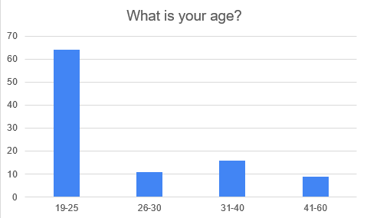

Figure 3.1 Question 1

According to the data collected the regarding age of those that responded to the survey the age group that stands out are those from the age of 19-25 being the majority by more than 60 respondents. With the lowest being the age group of 41-60 which has less than 10 respondents.

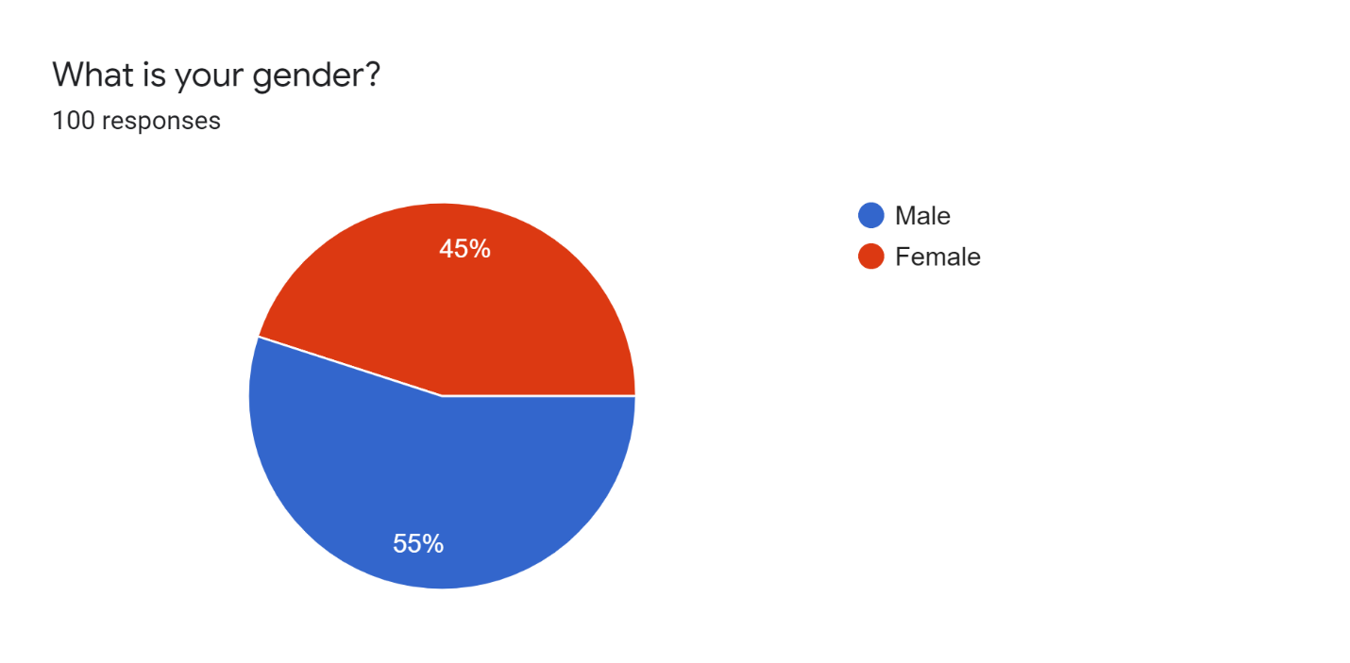

Figure 3.2 Question 2

In terms of the gender of the respondents the majority are male with 55 percent and females are following closely behind with 45 percent of respondents.

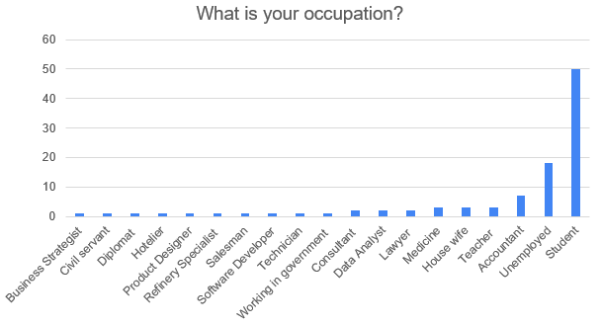

Figure 3.3 Question 3

Majority of the respondents are Students with 50 respondents with majority of the rest having a single respondent per category such as the business strategist and civil servant. Which shows that majority of the respondents either are unemployed or are students.

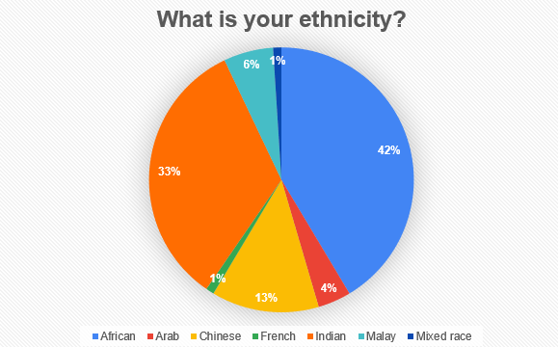

Figure 3.4 Question 4

The highest number of respondents were of an African ethnicity which had the largest percentage of 42 percent closely followed by Indian respondents with a percentage of 33 percent and the lowest were of French and Mixed race with 1 percent each. With the remaining being Chinese, Arab and Malay respondents with 13 percent, 4 percent and 6 percent respectively.

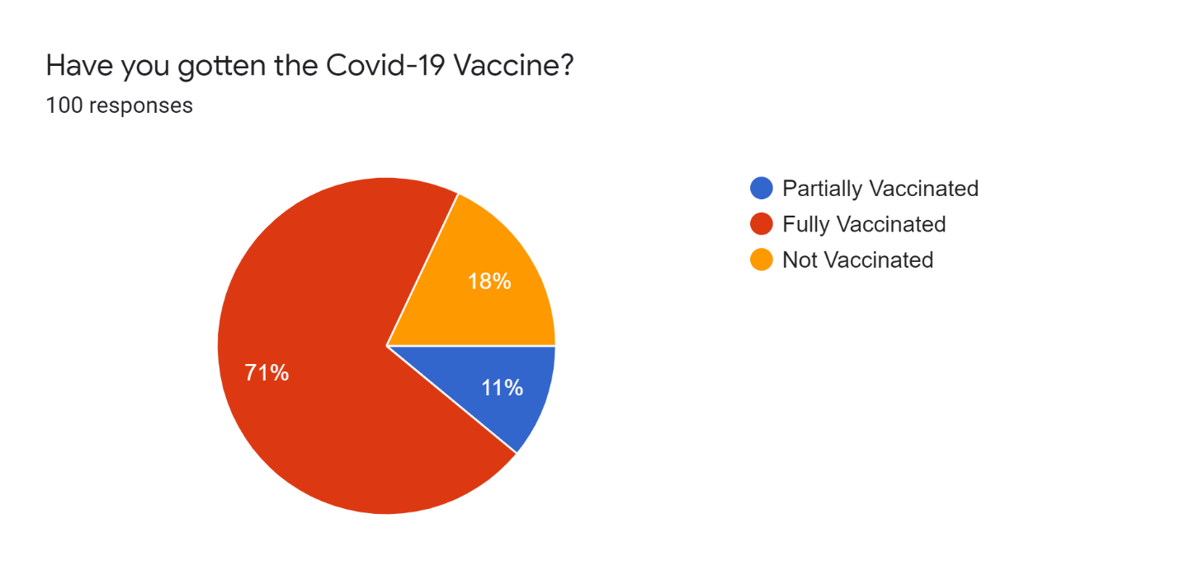

Figure 3.5 Question 5

A large number of respondents have been fully vaccinated with the percent being 71. There are 11 percent who are partially vaccinated and are the lowest number of respondents. Finally, there are those respondents who have not been vaccinated with 18 percent of respondents.

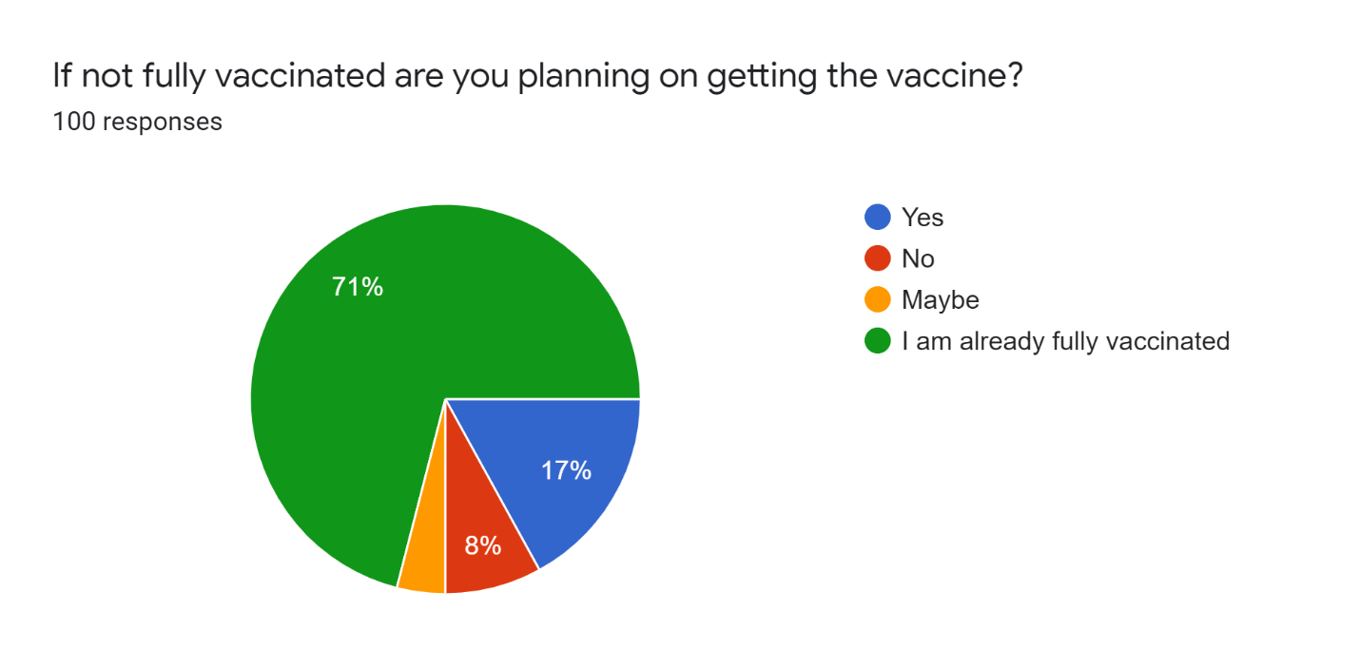

Figure 3.6 Question 6

According to the figure above the number of respondents who have been vaccinated are 71 percent. The respondents who are not vaccinated but plan to get vaccinated are 17 percent. Those who refuse to get vaccinated are 8 percent while the remaining are those who are undecided and they are in the minority with 4 percent.

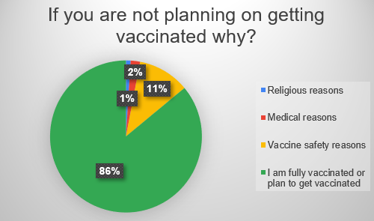

Figure 3.7 Question 7

Among those who are not planning to get vaccinated the lowest number of respondents said it was because of some medical reason with 1 percent. The highest reason why they are not planning on getting vaccinated has to do with vaccine safety concerns with 11 percent of respondents choosing that option. While the highest number of respondents have already gotten the vaccine with 86 percent.

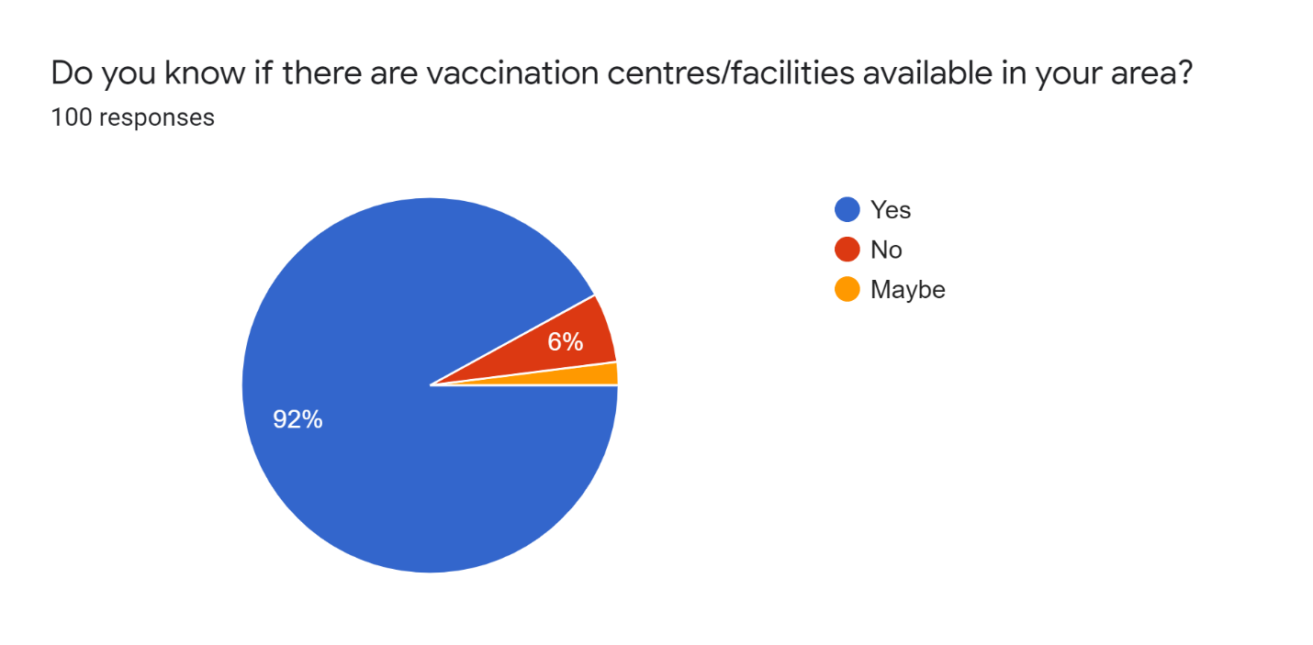

Figure 3.8 Question 8

Majority of the respondents know of the vaccination centres/ facilities that are available in the area with 92 percent. Among the respondents the lowest are unsure of whether there are any available facilities or centres with a low percentage of 2 percent being unsure. Finally, the respondents who don’t know about the availability of such facilities are still a low percent of 6.

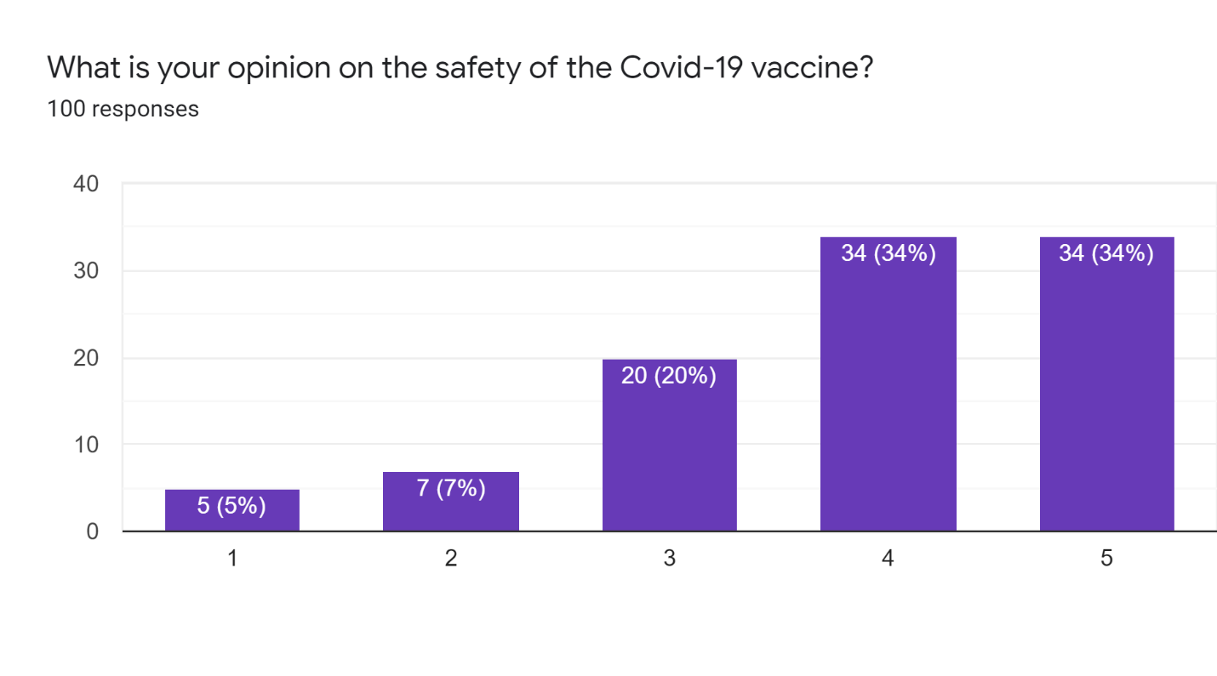Figure 3.9 Question 9

Majority of the respondents consider the vaccine at the very least to be relatively safe with 34 percent of the respondents considering it completely safe while another 34 percent considering it relatively safe. The rest of the respondents are either unsure of the safety of the vaccine or consider it completely unsafe with 5 percent of the respondents considering it completely unsafe, 7 percent consider it relatively unsafe while 20 percent are unsure or consider it equally safe and unsafe.

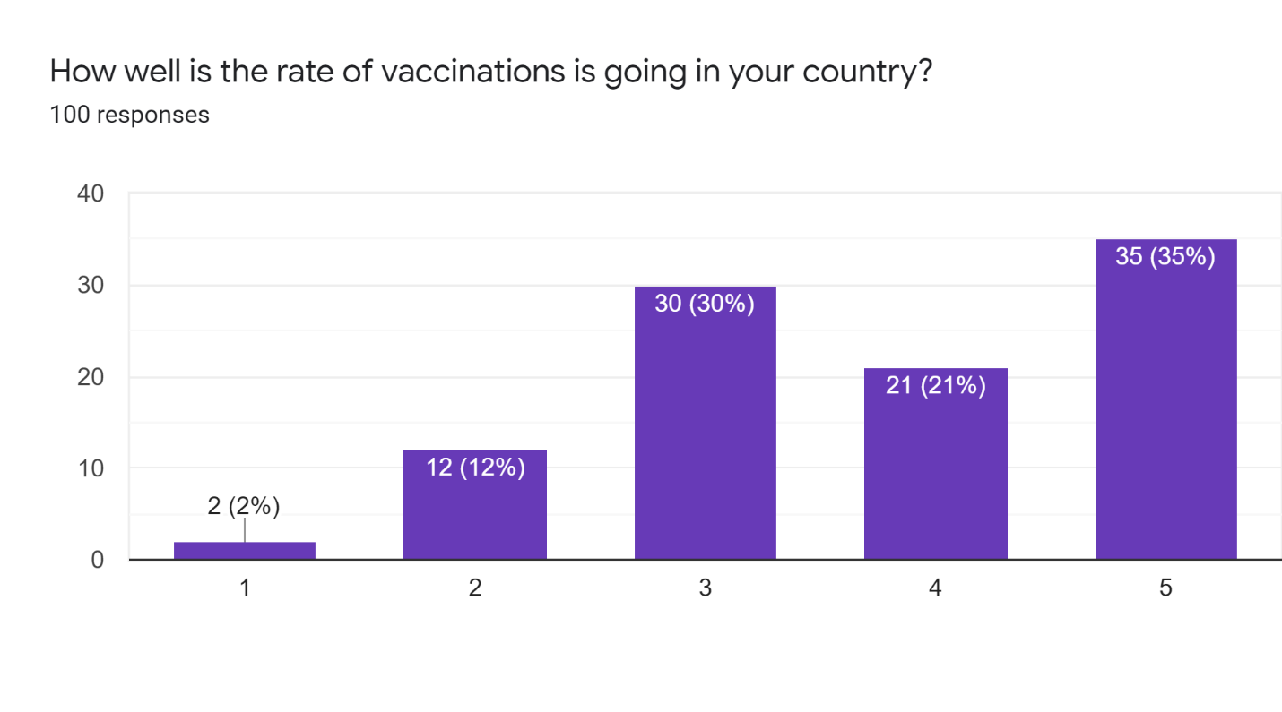

Figure 3.10 Question 10

Among the respondent’s majority believe that the rate of vaccination is going very well in their respective countries with the percentage being 35. A large percentage of the respondents are either unsure of the rate of vaccination or consider it to be neither good nor bad. 21 percent of respondents have the opinion that the rate of vaccination is going relatively well while the rest consider it to be going badly with 2 percent considering it to be going very badly while 12 percent considering it to be going relatively badly.

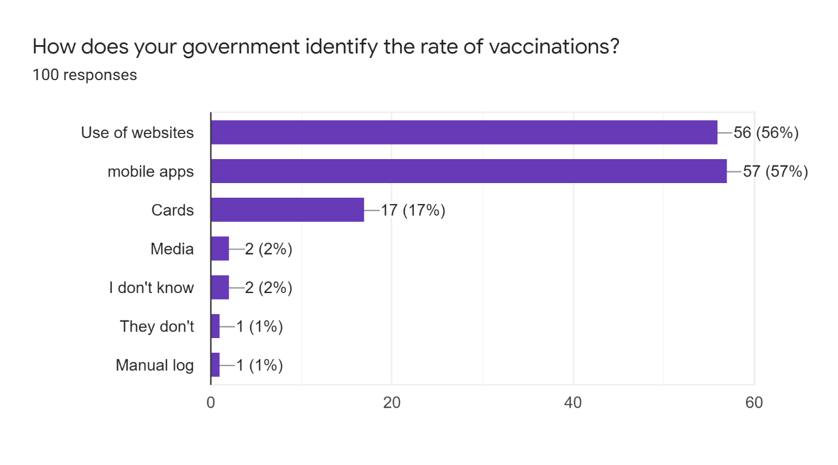

Figure 3.11 Question 11

According to the figure above majority of the respondent’s countries use mobile applications and websites to keep track of the rate of vaccinations with 57 percent saying that their government uses mobile applications and 56 percent saying that they use websites. From the figure above it can be extrapolated that some of the respondents believe that their government uses more than one method of keeping track of the rate of vaccination as can be seen by the high percentages of both choices of using websites and mobile applications. The rest of the respondents have responded that they either don’t know or that they make use of media, cards and manual logs.

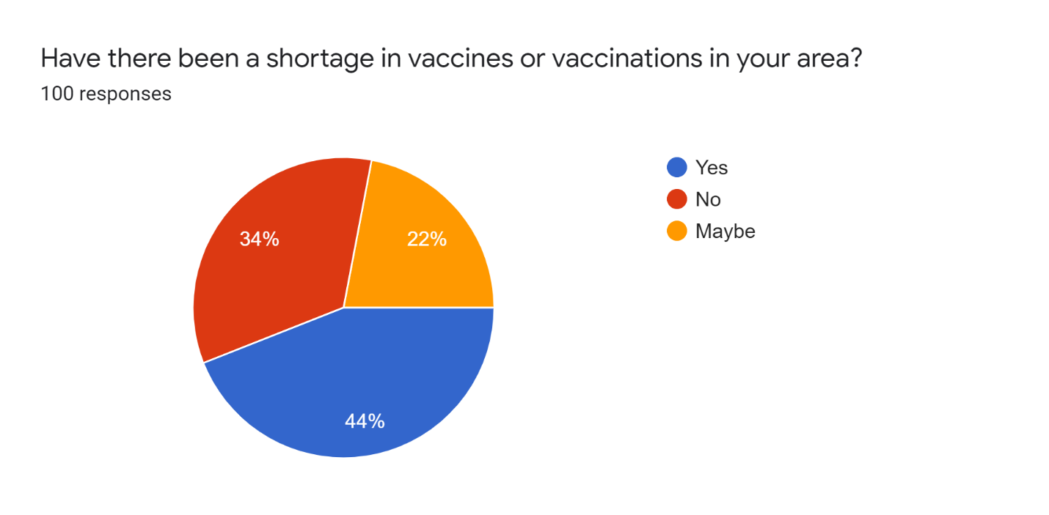

Figure 3.12 Question 12

Amongst the respondent’s majority have stated that there has been a shortage in their area while a nearly equal amount has stated the opposite that there hasn’t been a shortage in vaccines or vaccinations with 44 percent and 34 percent respectively. While on the lower level there are 22 percent of respondents are unsure of the situation in their area.

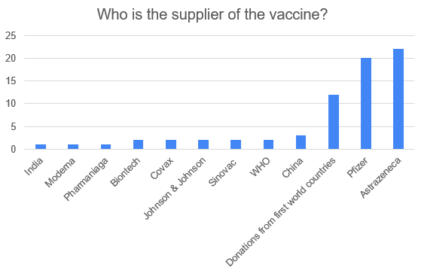

Figure 3.13 Question 13

According to figure 3.13 the highest number of respondents replied that the supplier of the vaccine is AstraZeneca with more than 20 respondents stating that AstraZeneca is the supplier with a close follow up by the respondents who replied that the supplier was Pfizer with 20 respondents and the rest providing their own answers on who the suppliers are with majority from those left replied that the supplier of the vaccines were donations from first world countries.

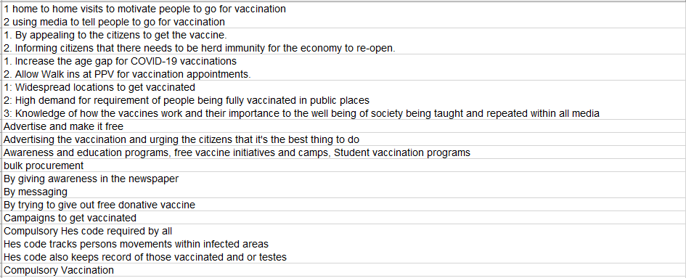

Figure 3.14 Question 14 part 1

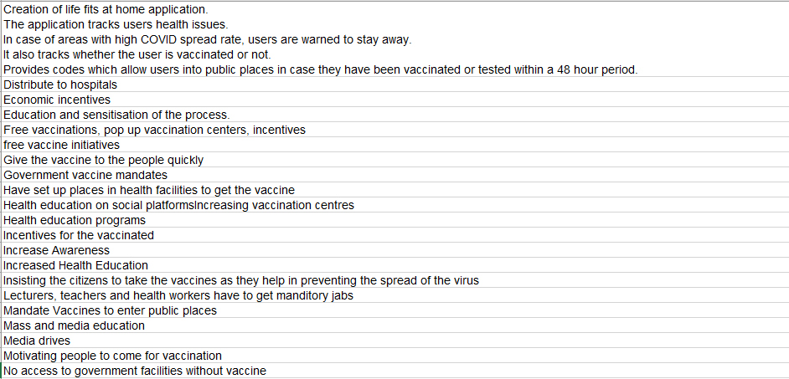

Figure 3.15 Question 14 part 2

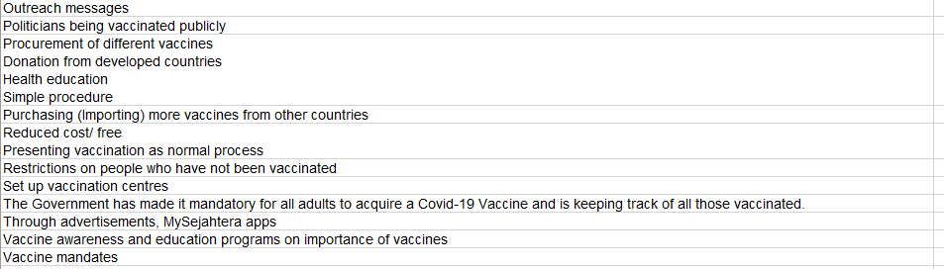

Figure 3.16 Question 14 part 3

Question 14 was an open-ended question with respondents providing a number of different suggestions with the question being “What steps has your government taken to increase vaccinations?” With majority of the respondents replying to some form of health education or vaccine awareness. There are a number of respondents who state that their governments have made vaccine mandates and have made it mandatory for their citizens to be vaccinated.

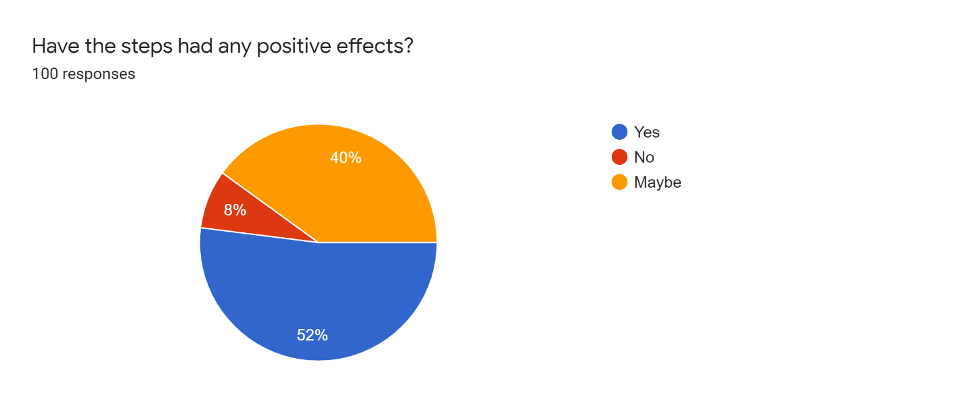

Figure 3.17 Question 15

Majority of the respondents believe that the steps their government has taken has a positive effect in the rate of vaccinations with 50 percent believing as such while a close 40 percent are unsure whether the steps the government has taken is having any positive effects while a low 4 percent of respondents believe that the steps taken by the government is having no positive effects on the rate of vaccination whatsoever.

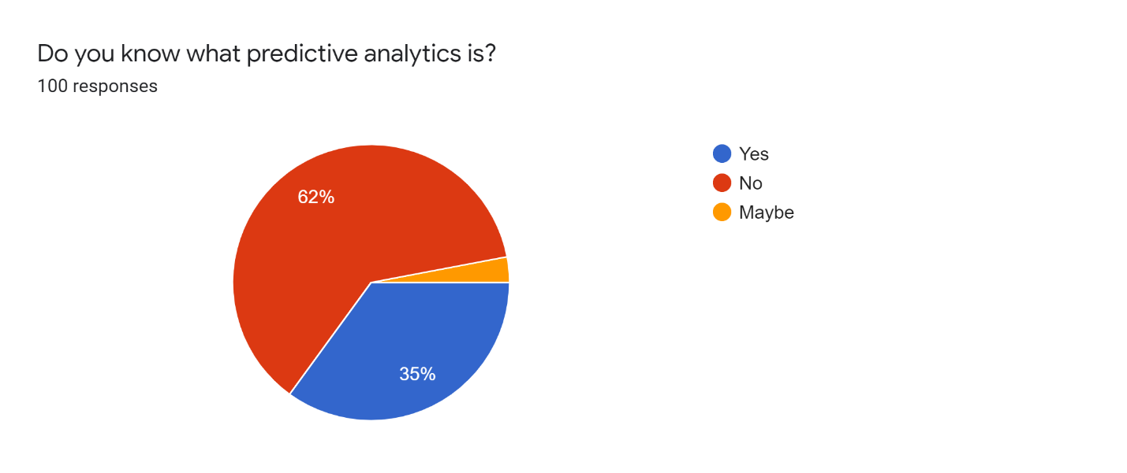

Figure 3.18 Question 16

According to the figure above 64 percent of respondent do not know what predictive analytics is. 35 percent of the respondents know what predictive analytics is while 3 percent of respondents are unsure regarding what predictive analytics is. This shows that a majority of people do not know what predictive analytics is and what it can be used for.

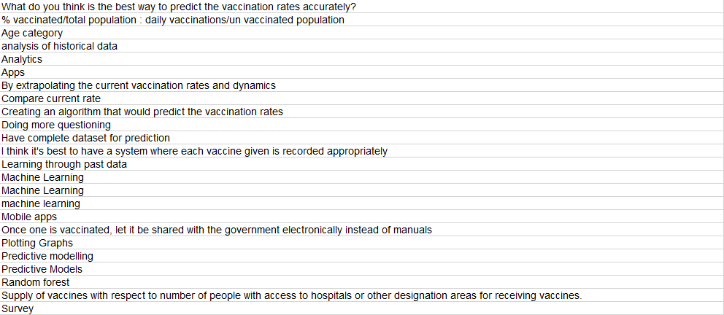

Figure 3.19 Question 17 part 1

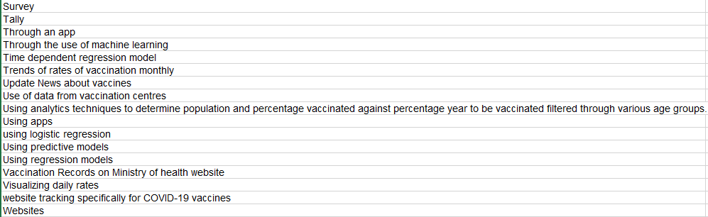

Figure 3.20 Question 17 part 2

Question 17 was another open-ended question which required the respondents to attempt to answer to the best of their ability. The question was “What do you think is the best way to predict the vaccination rates accurately?” There are a number of respondents who answered with machine learning, some answered with predictive models and other also answered with using websites and mobile applications. Some notable answered were the study of the current rate of vaccinations and the analysis of historical data.

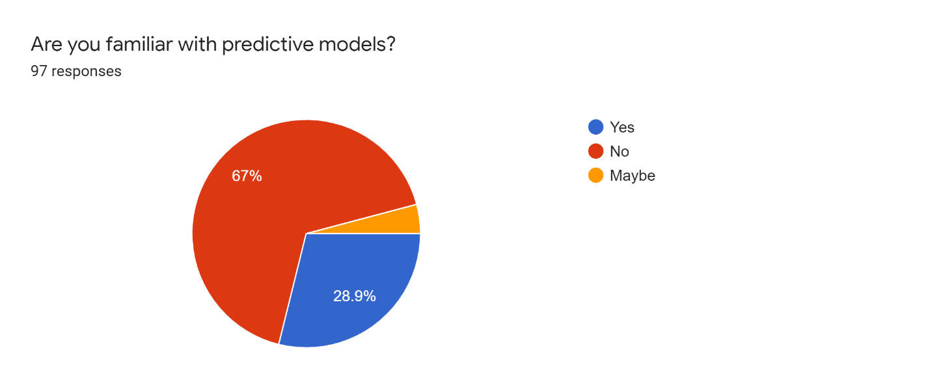

Figure 3.21 Question 18

Majority of the respondents are once again not familiar with predictive models with 67 percent choosing no as their answer. 28.9 percent have given an affirmative to knowing what predictive models are. While a small percentage of the respondents are unsure.

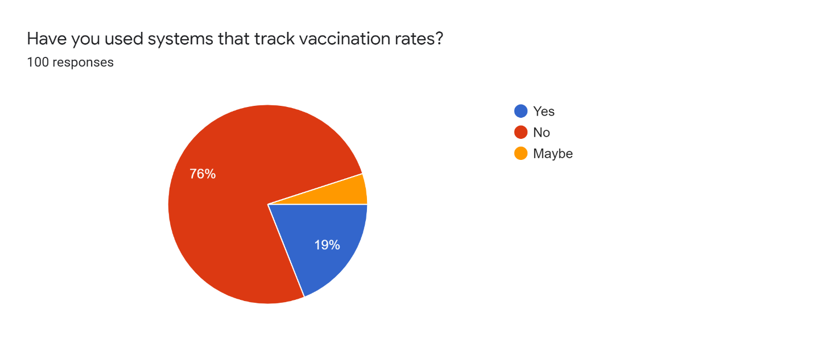

Figure 3.22 Question 19

When asked about using systems that track vaccination rates majority answered with not having experience using such systems with 76 percent choosing no. The rest either chose yes to having used such a system with 19 percent choosing yes and 5 percent being unsure whether they have or have not used such a system.

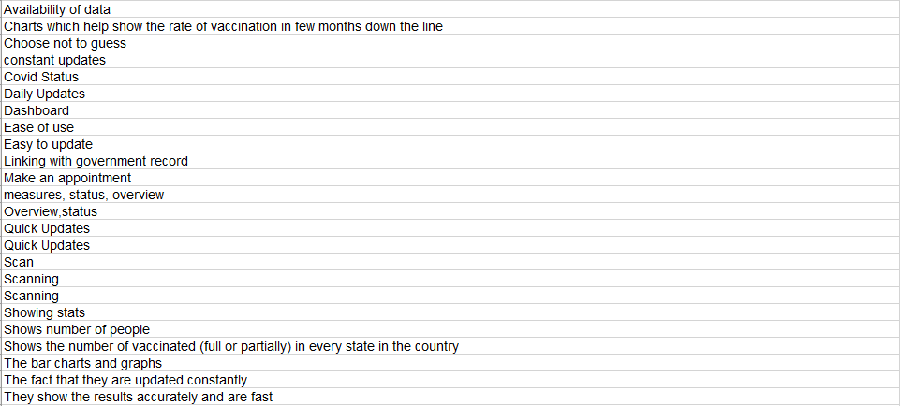

Figure 3.23 Question 20 part 1

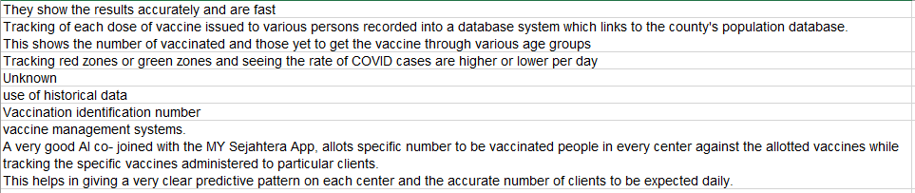

Figure 3.24 Question 20 part 2

Question 20 was another open-ended question that asked the respondents “What are the best features in existing systems?” Some notable answers by the respondents were the use of historical data, vaccine management systems, accurate and fast results, the use of a good ai with an example being given using the MYSejahtera application which allots a specific number of people to be vaccinated in every centre against the allotted vaccines while tracking the specific vaccines administered to each particular patient.

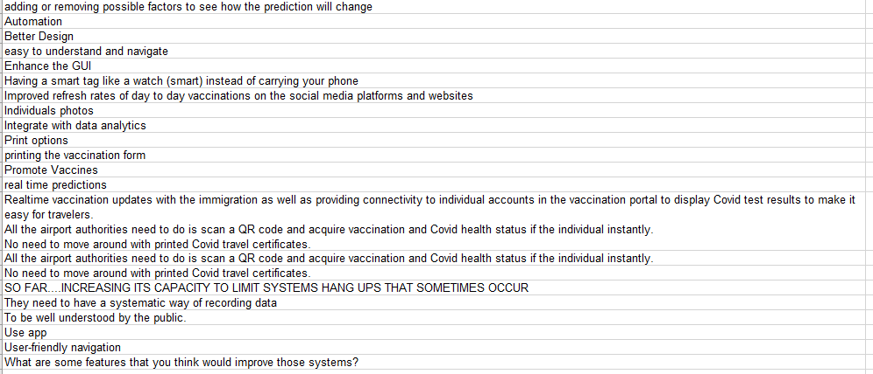

Figure 3.25 Question 21

The last question to be asked was “What are some features that you think would improve those systems?” With answers that are notable being that the system should be automated, should have better design and enhanced GUI, should integrate data analytics and should have print options. There are also a few who have mentioned that there should be real time analytics and should be well understood, easy to navigate and user-friendly.

## 3.3 Interview Planning and Analysis

### 3.3.1 Objectives

|  |  |  |  |
| --- | --- | --- | --- |
| **Question** | **Research Objectives** | **Research Questions** | **Interview Question** |
| **1** | Demographics | | What is your name? |
| **2** | What is your occupation? |
| **3** | To study and understand the current Covid-19 situation using the pandemic dataset and patient information, the research articles on the Pandemic Covid-19, the challenges faced by the health department in terms of logistic or patient management and the solutions implemented by Southeast Asia to increase the vaccination rates; | What are the factors that lead to the decrease in the percentage of vaccinations? | Has there been a decrease in the rate of people being vaccinated? |
| **4** | If there has been a decrease what are the reasons for it? |
| **5** | What are the factors that lead on the logistics for the vaccinations? | How and where are the vaccines stored and handled? |
| **6** | What is the process of administering the vaccine? |
| **7** | Are there any shortages of vaccines? |
| **8** | How are the vaccines transported and from where? |
| **9** |
| **10** | What are the factors that influence the health department on managing vaccinations? | what has impacted the rate of vaccinations? |
| **11** | What are the factors that were implemented to increase the percentage of vaccinations? | What steps have been taken to increase the number of vaccinations? |
| **12** | Have the steps taken helped in making a difference? |
| **13** | To perform predictive analytics using machine learning algorithm to measure the accuracy on the prediction of the percentage of vaccination rate; | How does the health department in identifying the vaccination rate of Covid-19? | What methods have been used to identify the number of people who have been vaccinated? |
| **14** | Which solution to apply on the prediction of the vaccination rate of Covid-19? | Do you know what predictive analytics is? |
| **15** | What do you think is the best way to predict the vaccination rates accurately |
| **16** | To implement the predictive model and to use the power of visualization by developing a user-friendly dashboard to visualize the rate of vaccinations. | Which algorithm have been applied in vaccination rate of Covid-19, what are the lacking and the performance measure from the past studies, which algorithms or techniques perform better than others and why? | Are you familiar with predictive models? |
| **17** | Have you used systems that track vaccinations? |
| What are some additional features that you think would improve those models? |

Table 3.3 Design Structure – Interview

### 3.3.2 Purpose of Interview Questions

|  |  |  |
| --- | --- | --- |
| **No.** | **Questions** | **Purpose** |
| **1** | What is your name? | Demographics |
| **2** | What is your occupation? |
| **3** | Has there been a decrease in the rate of people being vaccinated? | To find out the factors that are causing the vaccination rate to decrease. |
| **4** | If there has been a decrease what are the reasons for it? |
| **5** | How and where are the vaccines stored and handled? | To learn about the logistics of the vaccinations including the source of the vaccines, the handling and storage, the administering and the inventory. |
| **6** | What is the process of administering the vaccine? |
| **7** | Are there any shortages of vaccines? |
| **8** | How are the vaccines transported and from where? |
| **9** | what has impacted the rate of vaccinations? | To learn about the factors affecting the management of vaccinations |
| **10** | What steps have been taken to increase the number of vaccinations? | To learn about the steps taken and their effectiveness in increasing the rate of vaccinations |
| **11** | Have the steps taken helped in making a difference? |
| **12** | What methods have been used to identify the number of people who have been vaccinated? | To find out about the methods used in identifying the rate of vaccinations |
| **13** | Do you know what predictive analytics is? | To find out the best solution in predicting the rate of vaccinations. |
| **14** | What do you think is the best way to predict the vaccination rates accurately |
| **15** | Are you familiar with predictive models? | To find out about similar systems and what algorithms have been used and what features can be added to improve them. |
| **16** | Have you used systems that track vaccinations? |
| **17** | What are some additional features that you think would improve those models? |

Table 3.4 Purpose of Interview Questions

### 3.3.3 Interview Transcripts

#### 3.3.3.1 Transcript of interview – 1

Name: Dr Isaac Cheruiyot

Designation: Doctor

|  |  |
| --- | --- |
| Question 1: Has there been a decrease in the rate of people being vaccinated? | |
| **Response** | Yes |
|  | |
| Q2: If there has been a decrease what are the reasons for it? | |
| **Response** | Vaccine quantities depend on donations and in low- and middle-income countries donations are sparse thus there are few to no vaccinations. There is a decrease as most students in metropolitan have been vaccinated. While those in rural areas are not coming to cities to get vaccinated. To add rural programs are not as good as metropolitan ones. |
|  | |
| Q3: How and where are the vaccines stored and handled? | |
| **Response** | Ministry of health usually regulates the storage of vaccines |
|  | |
| Q4: What is the process of administering the vaccine? | |
| **Response** | Ministry of health programs through hospitals for public administration |
|  |  |
| Q5: Are there any shortages of vaccines? | |
| **Response** | Yes |
|  |  |
| Q6: How are the vaccines transported and from where? | |
| **Response** | I am uncertain of the exactly how and from where |
|  |  |
| Q7: what has impacted the rate of vaccinations? (whether positively or negatively) | |
| **Response** | There has been a positive impact through awareness of the vaccine and the vaccination process. |
|  |  |
| Q8: What steps have been taken to increase the number of vaccinations? | |
| **Response** | There has been a focus on health education and community programs |
|  |  |
| Q9: Have the steps taken helped in making a difference? | |
| **Response** | Yes |
|  |  |
| Q10: What methods have been used to identify the number of people who have been vaccinated? | |
| **Response** | Online database for ministry of health. |
|  |  |
| Q11: Do you know what predictive analytics is? | |
| **Response** | I am unsure |
|  |  |
| Q12: What do you think is the best way to predict the vaccination rates accurately? | |
| **Response** | Through the study of past patterns of similar cases |
|  |  |
| Q13: Are you familiar with predictive models? | |
| **Response** | I am not certain regarding that |
|  |  |
| Q14: Have you used systems that track vaccinations? | |
| **Response** | I have not made use of such systems as of yet |
|  |  |
| Q15: What are some additional features that you think would improve those models? | |
| **Response** | Realtime updates would be useful when using a system that can predict the rate of diseases or vaccinations. |

#### 3.3.3.2 Transcript of Interview – 2

Name: Dr Victor Mutua

Designation: Doctor

|  |  |
| --- | --- |
| Question 1: Has there been a decrease in the rate of people being vaccinated? | |
| **Response** | Yes |
|  | |
| Q2: If there has been a decrease what are the reasons for it? | |
| **Response** | Shortages in vaccines |
|  | |
| Q3: How and where are the vaccines stored and handled? | |
| **Response** | Regulations by the ministry of health |
|  | |
| Q4: What is the process of administering the vaccine? | |
| **Response** | Also regulated by the ministry of health |
|  |  |
| Q5: Are there any shortages of vaccines? | |
| **Response** | Yes |
|  |  |
| Q6: How are the vaccines transported and from where? | |
| **Response** | I am unsure of the process |
|  |  |
| Q7: what has impacted the rate of vaccinations? (whether positively or negatively) | |
| **Response** | Positive: health education  Negative: Cultural beliefs, doubts in the safety of the vaccine |
|  |  |
| Q8: What steps have been taken to increase the number of vaccinations? | |
| **Response** | Educating the public |
|  |  |
| Q9: Have the steps taken helped in making a difference? | |
| **Response** | Yes |
|  |  |
| Q10: What methods have been used to identify the number of people who have been vaccinated? | |
| **Response** | Registration and tracking on ministry of health website |
|  |  |
| Q11: Do you know what predictive analytics is? | |
| **Response** | yes |
|  |  |
| Q12: What do you think is the best way to predict the vaccination rates accurately? | |
| **Response** | View vaccination for other diseases and the pattern of covid vaccination over time |
|  |  |
| Q13: Are you familiar with predictive models? | |
| **Response** | I am unsure of what predictive models are |
|  |  |
| Q14: Have you used systems that track vaccinations? | |
| **Response** | I have not made use of such systems |
|  |  |
| Q15: What are some additional features that you think would improve those models? | |
| **Response** | Tracking individual vaccine statuses |

#### 3.3.3.3 Transcript of Interview – 3

Name: Dr Shehnaz Harunani

Designation: Doctor

|  |  |
| --- | --- |
| Question 1: Has there been a decrease in the rate of people being vaccinated? | |
| **Response** | No |
|  | |
| Q2: If there has been a decrease what are the reasons for it? | |
| **Response** | There hasn’t been a noticeable decrease |
|  | |
| Q3: How and where are the vaccines stored and handled? | |
| **Response** | I am unsure of the process of how vaccines are stored |
|  | |
| Q4: What is the process of administering the vaccine? | |
| **Response** | The vaccine is administered as an intramuscular injection in the deltoid muscle of the left upper limb |
|  |  |
| Q5: Are there any shortages of vaccines? | |
| **Response** | Yes |
|  |  |
| Q6: How are the vaccines transported and from where? | |
| **Response** | I am uncertain how and from where the vaccines are transported |
|  |  |
| Q7: what has impacted the rate of vaccinations? (whether positively or negatively) | |
| **Response** | Positive: The decision of the government not to permit unvaccinated people in public places  Negative: Propaganda that vaccines cause side effects such as infertility |
|  |  |
| Q8: What steps have been taken to increase the number of vaccinations? | |
| **Response** | Recently the government’s directive that those not vaccinated will not be allowed in public places  Need for vaccination certificate in case one needs to travel by air |
|  |  |
| Q9: Have the steps taken helped in making a difference? | |
| **Response** | Yes |
|  |  |
| Q10: What methods have been used to identify the number of people who have been vaccinated? | |
| **Response** | Data collection at the time of vaccination. Patients are registered into an online database prior to vaccine administration |
|  |  |
| Q11: Do you know what predictive analytics is? | |
| **Response** | No |
|  |  |
| Q12: What do you think is the best way to predict the vaccination rates accurately? | |
| **Response** | Using graphs which record the uptake of vaccinations over time. These graphs can be extrapolated and will be helpful in projecting the future vaccination rates. |
|  |  |
| Q13: Are you familiar with predictive models? | |
| **Response** | No |
|  |  |
| Q14: Have you used systems that track vaccinations? | |
| **Response** | No |
|  |  |
| Q15: What are some additional features that you think would improve those models? | |
| **Response** | I don’t know |

#### 3.3.3.4 Transcript of Interview – 4

Name: Dr. Walid Mohammed Designation: General Practitioner

|  |  |
| --- | --- |
| Question 1: Has there been a decrease in the rate of people being vaccinated? | |
| **Response** | Yes |
|  | |
| Q2: If there has been a decrease what are the reasons for it? | |
| **Response** | Initially the focus was on medical staff and most are now vaccinated. The public / society are still hesitant to vaccinate due to various myths. Vaccine availability in some areas also a factor. Preference by some people to only get a single shot (J&J) yet it’s not available everywhere |
|  | |
| Q3: How and where are the vaccines stored and handled? | |
| **Response** | Cold chain process is followed well |
|  | |
| Q4: What is the process of administering the vaccine? | |
| **Response** | Routine as with other vaccines normally given example being childhood vaccinations |
|  |  |
| Q5: Are there any shortages of vaccines? | |
| **Response** | Some brands examples being J&J |
|  |  |
| Q6: How are the vaccines transported and from where? | |
| **Response** | From the central storage areas to vaccine centres in appointed hospitals |
|  |  |
| Q7: what has impacted the rate of vaccinations? (whether positively or negatively) | |
| **Response** | Myths on vaccinations – negative |
|  | |
| Q8: What steps have been taken to increase the number of vaccinations? | |
| **Response** | Sensitization and awareness on importance and benefits of vaccinations Vaccine drives through religious institutions |
|  |  |
| Q9: Have the steps taken helped in making a difference? | |
| **Response** | There’s increased uptake but still a large number not vaccinated |
|  |  |
| Q10: What methods have been used to identify the number of people who have been  vaccinated? | |
| **Response** | Government registry |
|  |  |
| Q11: Do you know what predictive analytics is? | |
| **Response** | No |
|  |  |
| Q12: What do you think is the best way to predict the vaccination rates accurately? | |
| **Response** | Using data from previous months |
|  |  |
| Q13: Are you familiar with predictive models? | |
| **Response** | No |
|  |  |
| Q14: Have you used systems that track vaccinations? | |
| **Response** | No |
|  |  |
| Q15: What are some additional features that you think would improve those models? | |
| **Response** | -- |

#### 3.3.3.5 Transcript of Interview – 5

Name: Dr Farha Harunani

Designation: medical officer

|  |  |
| --- | --- |
| Question 1: Has there been a decrease in the rate of people being vaccinated? | |
| **Response** | No |
|  | |
| Q2: If there has been a decrease what are the reasons for it? | |
| **Response** | N/A |
|  | |
| Q3: How and where are the vaccines stored and handled? | |
| **Response** | They are stored in the fridge at the vaccination center then removed during vaccine administration |
|  | |
| Q4: What is the process of administering the vaccine? | |
| **Response** | Intramuscular injection |
|  |  |
| Q5: Are there any shortages of vaccines? | |
| **Response** | Yes |
|  |  |
| Q6: How are the vaccines transported and from where? | |
| **Response** | Transported from ministry of health offices in cooler boxes |
|  |  |
| Q7: what has impacted the rate of vaccinations? (whether positively or negatively) | |
| **Response** | Mass education on benefits of getting vaccinated has had a positive impact whereas myths on social sites on side effects and deaths following vaccination has had a negative impact |
|  |  |
| Q8: What steps have been taken to increase the number of vaccinations? | |
| **Response** | Laws making vaccination a requirement such as to travel out of the country  Educating the public on benefits of vaccination |
|  |  |
| Q9: Have the steps taken helped in making a difference? | |
| **Response** | Yes |
|  |  |
| Q10: What methods have been used to identify the number of people who have been vaccinated? | |
| **Response** | Recording in national data collection software platforms |
|  |  |
| Q11: Do you know what predictive analytics is? | |
| **Response** | Yes |
|  |  |
| Q12: What do you think is the best way to predict the vaccination rates accurately? | |
| **Response** | Having a common data base on daily vaccine administration |
|  |  |
| Q13: Are you familiar with predictive models? | |
| **Response** | No |
|  |  |
| Q14: Have you used systems that track vaccinations? | |
| **Response** | No |
|  |  |
| Q15: What are some additional features that you think would improve those models? | |
| **Response** | N/A |

#### 3.3.3.6 Transcript of Interview – 6

Name: Mohamed M Hassan

Designation: medical officer

|  |  |
| --- | --- |
| Question 1: Has there been a decrease in the rate of people being vaccinated? | |
| **Response** | No |
|  | |
| Q2: If there has been a decrease what are the reasons for it? | |
| **Response** | N/A |
|  | |
| Q3: How and where are the vaccines stored and handled? | |
| **Response** | Stored In the fridge at the vaccination center and only removed during vaccine administration |
|  | |
| Q4: What is the process of administering the vaccine? | |
| **Response** | Intramuscular injection |
|  |  |
| Q5: Are there any shortages of vaccines? | |
| **Response** | Yes |
|  |  |
| Q6: How are the vaccines transported and from where? | |
| **Response** | Transported in cooler boxes from ministry of health offices |
|  |  |
| Q7: what has impacted the rate of vaccinations? (whether positively or negatively) | |
| **Response** | Positive impact from the outcome of severely infected patients' relatives  Negative impact from myths regarding possible side effects |
|  |  |
| Q8: What steps have been taken to increase the number of vaccinations? | |
| **Response** | Mandatory civil servant vaccination policies  Mass education |
|  |  |
| Q9: Have the steps taken helped in making a difference? | |
| **Response** | Partially. Much more can be done |
|  |  |
| Q10: What methods have been used to identify the number of people who have been vaccinated? | |
| **Response** | Recording in national data collection software platforms |
|  |  |
| Q11: Do you know what predictive analytics is? | |
| **Response** | Yes |
|  |  |
| Q12: What do you think is the best way to predict the vaccination rates accurately? | |
| **Response** | Prediction does not aid outcome. |
|  |  |
| Q13: Are you familiar with predictive models? | |
| **Response** | No |
|  |  |
| Q14: Have you used systems that track vaccinations? | |
| **Response** | No |
|  |  |
| Q15: What are some additional features that you think would improve those models? | |
| **Response** | Unsure |

### 3.3.4 Analysis

Question 1 and 2

When asked about whether there has been a decrease in the rate of people being vaccinated three of the interviewees stated that there was a decrease while the rest of the interviewees believe that there is no decrease in the rate of people being vaccinated.

When asked about the reason for why there is a decrease in vaccination the three interviewees who stated there was a decrease had different answers. The answers seem to indicate there are a number of reasons why the rate of vaccination has reduced. One of the reasons is that vaccine quantities depend on donations and countries in the low- and middle-income range are not getting enough donations which has caused fewer vaccinations due to there being less vaccines and to add on top of that majority of the health workers and students have gotten vaccinated in the metropolitan areas. While that is true the citizens in the rural areas have difficulty getting vaccinated as the vaccination programs are not as apt as the ones in the cities. There is also a reduction in the number of vaccinations due to hesitancy in taking the vaccine as there are numerous myths regarding the vaccine. There is also preference to a specific vaccine type such as Johnson and Johnson which is not available everywhere. The rest of the interviewees have stated that there has not been a noticeable change in rate of vaccinations.

Question 3

Two interviewees stated that the storage and handling of the vaccines is usually regulated by the ministry of health while another two have stated that the process of storing of the vaccines uses a process called cold chain process, which is a logistics management process for products that require low temperatures and t's a procedure which entails a series of steps to prepare, store, and transport items across the cold supply chain, which is stated to being followed well and that the only time the vaccines are removed from their cold storage is when they are being used for administration. The last interviewee has stated that they are unsure of the process involved around the storage and handling of the vaccines. It can be surmised that the vaccines require low temperatures and care in order to be useful and if the process known as cold chain process is not followed well can spoil the vaccines. As stated, it is a process that is being followed well by the people handling and storing the vaccines.

Question 4

Among the interviewees two of them mentioned the administration of the vaccine is as an intramuscular injection in the deltoid muscle of the upper limb, which is a large triangle shaped muscle associated with the human shoulder girdle, which is a similar process to the administration of vaccines to children such as the rotavirus vaccine and hepatitis B vaccine. The final two interviewees mentioned that the process of administering the vaccines is regulated by the ministry of health same as the storage and handling of the vaccine.

Question 5

When asked regarding the shortage of vaccines all of the interviewees provided the same answers of affirmation that there has been a shortage of vaccines and one interviewee went further to inform that there has been a shortage of vaccines mostly for some brands such as Johnson and Johnson. This can be used to surmise that there might be other vaccines that are available but mainly specific brands of vaccines are the ones that are lacking in availability.

Question 6

Half of the interviewees are uncertain of the process of how the vaccines are transported as well as where the vaccines are coming from. The other half of the interviewees have shed light on the process by stating that the vaccines come from the central storage areas and from the ministry of health offices to the appointed hospitals in cooler boxes to keep the vaccines in the right conditions to be administered.

Question 7

When asked about the what factors have impacted the rate of vaccinations the interviewees have provided answers which are both positive and negative with the positive being that the relatives of severely infected patients would get the vaccine in fear of catching the illness themselves, there has been mass education on the benefits of getting the vaccine which has had a positive impact with people gaining an understanding and getting the vaccine thus increasing the rate of vaccinations, the government making the decision to not permit unvaccinated people in public places thus forcing people to get vaccinated and there has been greater awareness of the vaccine and the process of getting vaccinated which has impacted the rate of vaccinations positively. While on the other hand there are factors that have negatively impacted the rate of vaccination these are such as myths regarding possible side effects from the vaccine is causing people to be dissuaded from getting the vaccine, false news on social media sites regarding deaths and side effects followed by getting the vaccine has effected the rate of vaccination negatively, propaganda on side effects such as infertility being caused by the vaccines and cultural beliefs and doubts in the safety of the vaccine has caused a negative impact on the rate of vaccinations.

It can be seen that majority of the reason that have to do with low vaccination rates seem to have to do with people’s perception of the vaccines causing harmful side effects such as infertility and death especially through stories on social media and other platforms that are spreading such myths. There is also a cultural belief against taking the vaccine which has prevented people of going to get vaccinated all of which is negatively impacting the rate of vaccinations.

While for the positives the more aware people become on the benefits of getting vaccinated as well as being educated regarding their health and safety is causing them to get vaccinated. Besides that, the government’s attempts to get people vaccinated by not permitting unvaccinated people to come to public areas forces people to get vaccinated thus increasing the rate of vaccinations.

Question 8

According to the interviewees there are a number of steps that have been taken to increase the number of vaccinations such as making vaccine mandates for civil servants using vaccination policies as well as creating policies that require people to get vaccinated prior to being allowed to travel outside of the country. There are also government directives that prohibit unvaccinated people from being allowed in public places as well as requiring a vaccine certificate in order to travel by air. There have also been steps taken in order to educate the public through health education and community programs as well as spreading the sensitization and awareness on importance and benefits of vaccinations. Besides that, there are also vaccination drives through religious organizations which push people to getting the vaccine.

Question 9

When asked whether the steps have made a significant difference majority of the interviewees responded in the positive while two of the interviewees states that despite the increased uptake in the rate of vaccination there are a lot of people that have yet to take the vaccine and that there is a lot more that could be done to increase the rate of vaccinations.

Question 10

When asked about how the government identifies the number of people who have been vaccinated two interviewees responded that there is a national data collection software that is used by the government to collect the data on the vaccination status of the people. Another interviewee stated that they used a government registry. While the three other interviewees mentioned an online data base or website for the ministry of health that is used to collect data during the time of vaccination where patients are registered prior to receiving the vaccine. Thus, it can be extrapolated from the interviewees answers that there is a website or online database or software that is being used by the government where data is collected during the time of vaccination where a patient is required to register and the status of vaccination is updated prior to getting the vaccine.

Question 11

Three of the interviewees have given a positive answer when asked whether they know of what predictive analytics is while two of the interviewees answered in the negative and finally the remaining interviewee answered with uncertainty.

Question 12

The interviewees were asked about the best way to predict the vaccination rates accurately one of the interviewees answered that predicting the rate of vaccination would not aid the outcome, another answered that using a common database on the daily vaccine administrations would assist in making accurate predictions, using the data from previous months to extrapolate future values, use of graphs which record the uptake of the vaccines over time can be helpful in projecting future vaccination rates, using the vaccination rates of other illnesses and looking at the pattern of covid-19 vaccinations over time would help in the prediction process and finally through the study of similar cases.

Question 13

All of the interviewees answered negatively or with uncertainty when asked whether they knew what predictive models are.

Question 14

When asked whether they have used systems that can track the rate of vaccinations every one of the interviewees responded that they had not made use of such systems.

Question 15

The interviewees were asked whether they were some additional features that they could think of that would improve models that could track vaccinations and most of them responded negatively or with uncertainty while two interviewees responded that the model could have features such as real time updates in the system and a feature that could track the vaccination status of each individual.

## 3.4 Functional and Non-Functional Requirements

Requirements generally allow for the success of a system or software project to be tested. There are two types of requirements these are the functional and non-functional requirements.

Functional Requirements are those that the end user specifically demands as basic features that the system should have. Non-functional requirements, on the other hand, are the quality limitations that the system must meet in order to fulfill the project contract.

### 3.4.1 Functional Requirements

* Allows users to register to the system
* Allows users to login using their account after registration
* Allows users to choose between a list of countries for the predictions
* Allows users to pick the date to create a range for the predictions
* Allows users to compare the predictions between two or more countries

### 3.4.2 Non-Functional Requirements

* The graphs must be clearly labelled and easy to read
* The information must be understandable
* The system must be user-friendly
* Should have clear differences between different variables such as the different countries
* The system should be easy to navigate and use

## 3.5 System Design

### 3.5.1 Rich Picture Diagram

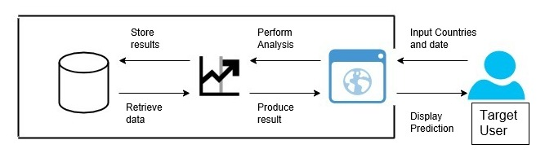

Figure 3.26 Rich Picture Diagram

### 3.5.2 Use Case Diagram

#### 3.5.2.1 Actors and Use Cases

|  |  |  |  |  |
| --- | --- | --- | --- | --- |
| Actor | Actor Description |  | Use Case | Use Case Description |
| User | User is the representative of the System user which would be the policy makers or hospital staff | Initiates | Select country | The user will have to choose one country or more to see the predictions on the rate of vaccinations in that area and if more than one country is chosen a comparison can be made between the predictions of the two or more countries. |
| Select date | The user has to select a date so that they can see the predictions from the current date to the date chosen |
| View Prediction | The user can check view the prediction after selecting the countries and the date |
| Login | The user has to login prior to being able to interact with the system in any significant way |
| Logout | The user can logout of the system after they are done |
| Register | The user is unable to login without registering into an account in the system |

Table 3.5 Actor and Use Cases

#### 3.5.2.2 Login and Registration Diagram

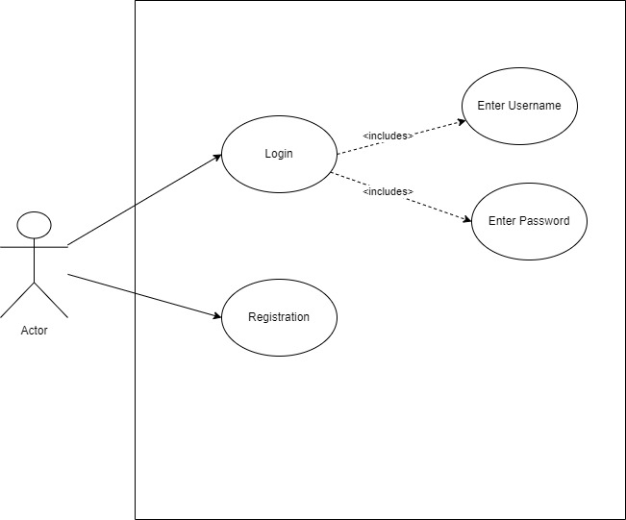

Figure 3.27 Login and Registration Diagram

#### 3.5.2.3 Rate of Vaccination Prediction Diagram

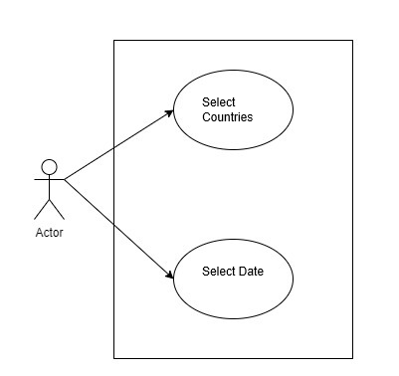

Figure 3.28 Rate of Vaccination Prediction Diagram

### 3.5.3 Activity Diagram

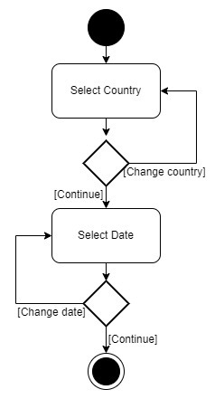

Figure 3.29 Display Vaccination Prediction Diagram

### 3.5.4 System Process Diagram

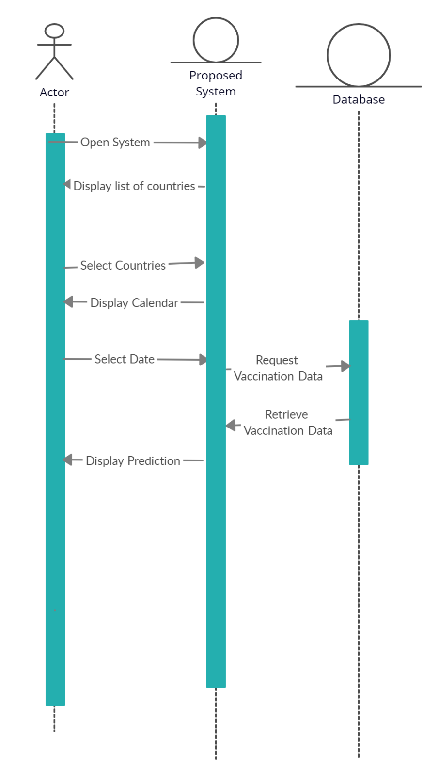

Figure 3.30 System Process Diagram

## 3.6 User Interface Design

### 3.6.1 Login and Registration Page

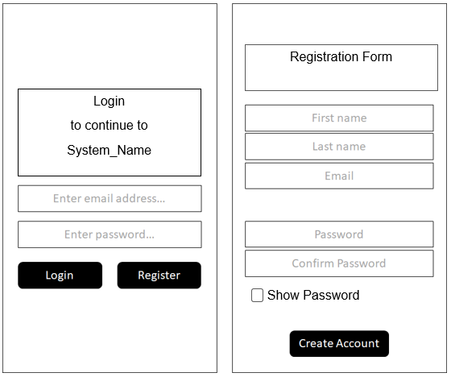

Forgot Password

Figure 3.31 Login and Registration Pages

Figure 3.5 shows two pages of the user interface design these are the login and interface pages where the user can register into the system through an email account and then login using the registered account. They can then access the other pages in order to be able to see the predictions for the countries and date range they have chosen.

### 3.6.2 Select Countries

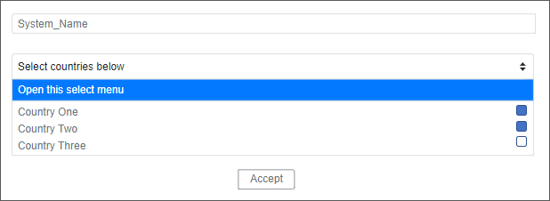

Figure 3.32 Country Selection Page

The figure above shows the page where a user can choose one or more countries to see the prediction on their rate of vaccinations. The system will show a drop box which will have the name of the countries that the user can choose or more of and then once the user is satisfied with their choice, they can click the button accept to continue onto the next page which is the select date page.

### 3.6.2 Select Date

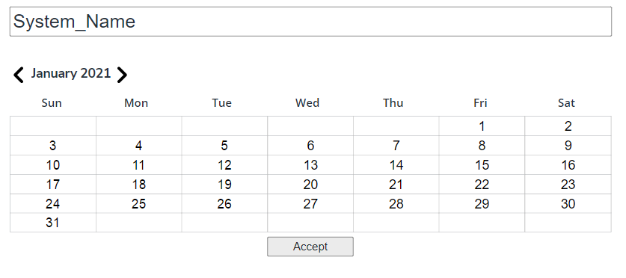

Figure 3.33 Date Selection Page

The date selection page is where the user will be redirected to after they have completed picking the country or more, they wish to see the prediction of the rate of vaccination. They can choose the date which is the end date until when they want to see the rate of prediction for the chosen countries with the start date being the current date. After they have chosen their date the user can once again click on the accept button which will redirect them to the prediction display page where they can see the predictions for the countries and the prediction until the chosen date.

### 3.6.3 Display Page

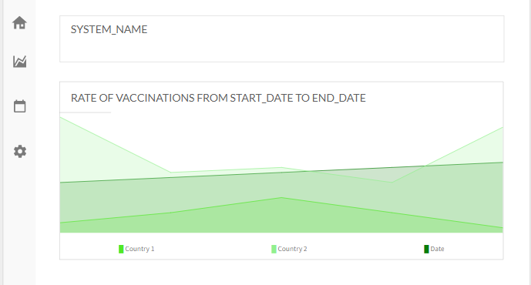

Figure 3.34 Vaccination Prediction Page

On this page the user is shown a graph with vaccination predictions of the chosen countries and the date range from the current date until the chosen date. The prediction displayed can be of multiple countries which allow for easier comparison on which countries rate of vaccination is going better.

## 3.7 Summary

There are advantages and disadvantages to using any tool and data gathering tools are no exception especially when using Interviews and Questionnaires. The use of these tools to gather data and then analyse that data from random people and front liners than analysing that data to extrapolate ideas and information regarding the logistic process of vaccinations, the management of vaccinations and the reason for low vaccination rates. The author has also made use of multiple diagrams such as rich-picture diagram, use case diagram, activity diagram and sequence diagram. Finally, there are prototypes of what the proposed system’s interface would look like.

# References

Bell, S. and Morse, S., 2012. How People Use Rich Pictures to Help Them Think and Act. Systemic Practice and Action Research, 26(4), pp.331-348.

Debois, S., 2021. 10 Advantages and Disadvantages of Questionnaires - Survey Anyplace. [online] Survey Anyplace. Available at: <https://surveyanyplace.com/blog/questionnaire-pros-and-cons/> [Accessed 24 November 2021].

GeeksforGeeks. 2021. Unified Modeling Language (UML) | Activity Diagrams - GeeksforGeeks. [online] Available at: <https://www.geeksforgeeks.org/unified-modeling-language-uml-activity-diagrams/#:~:text=An%20activity%20diagram%20is%20a> [Accessed 24 November 2021].

Sites.google.com. 2021. 3.2.1 Use Case Tables - SHU Practical Computing Project. [online] Available at: <https://sites.google.com/site/louismccallapcp/home/development/use-cases/use-case-tables> [Accessed 24 November 2021].

# Appendix